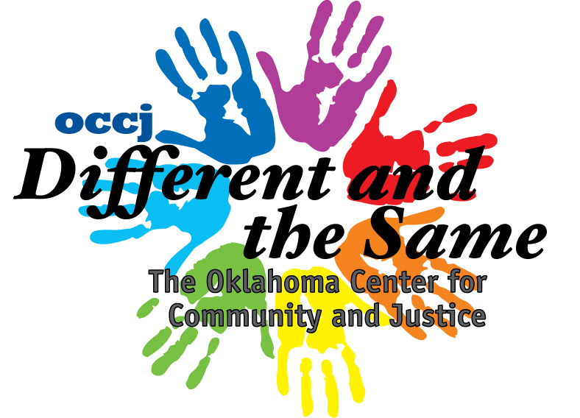

Your Name: ____________________
Partners Name: ______________________

Language Questionnaire

- What languages do you speak?
__________________________________________________________________________________________________________________________________________________________________________________

- What languages do your parents speak?
__________________________________________________________________________________________________________________________________________________________________________________

- What languages do your grandparents speak?
__________________________________________________________________________________________________________________________________________________________________________________

