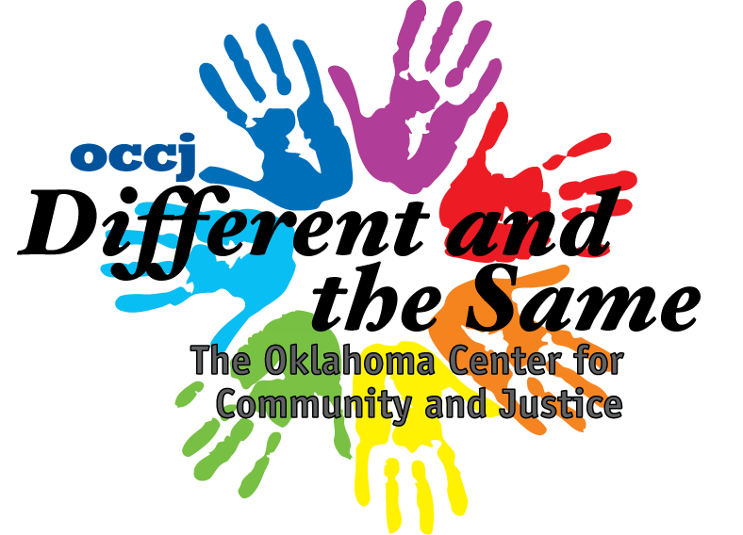

Your Name: ____________________
Your Culture: ______________________

Culture Questionnaire

- What country did your ancestors come from?
__________________________________________________________________________________________________________________________________________________________________________________
- What language did you ancestors speak?
__________________________________________________________________________________________________________________________________________________________________________________
- What kinds of clothing did your ancestors wear?
__________________________________________________________________________________________________________________________________________________________________________________
- What kinds of food did your ancestors cook?
__________________________________________________________________________________________________________________________________________________________________________________
- What kind of activities are part of your culture?
__________________________________________________________________________________________________________________________________________________________________________________

